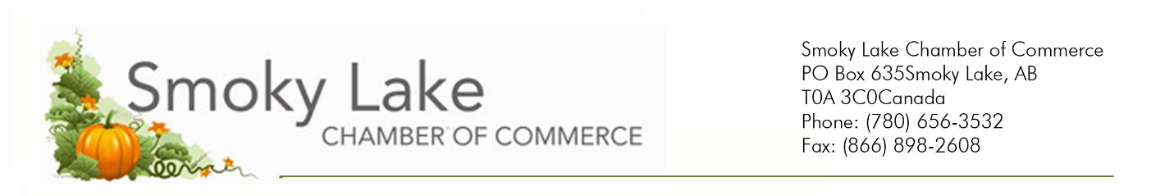

October 13, 2023

Re: Community Christmas Party

Dear Business owner, Community Organization or Community Member,

The Smoky Lake Regional Chamber of Commerce is hosting a Community Christmas Party, December 2, 2023, at Métis Crossing (poster attached).

Everyone is welcome, and tickets are priced at $70 per person and includes a fabulous meal and entertainment by Tone Traveler.

Please consider bringing a group for the event, it promises to be a great evening of dining and dancing for the holiday season.

Ticket sales close November 12th and we will proceed with the event with 100 tickets or more sold.

Accommodations are available by calling The Lodge 780 656 2224 and if there is interest, we will run a shuttle between the site and Smoky Lake for a small fee/donation.

Sincerely,

Noel Simpson,
President, Smoky Lake Regional Chamber of Commerce

